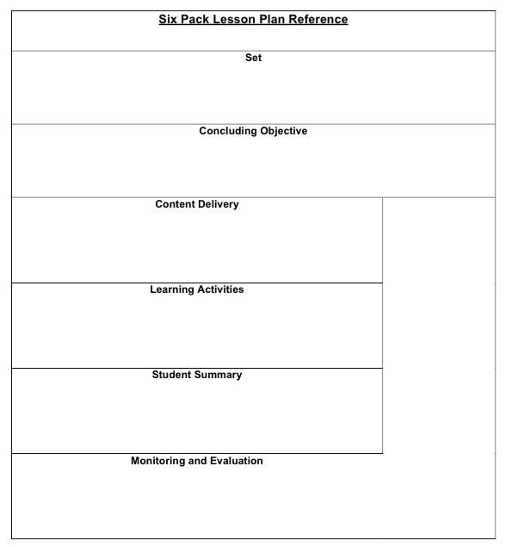

* This lesson is intended to be a portion of the broader skill of Assessment. By allowing students to learn in Mini Lesson format with smaller content mastery, the goal is to develop a strong foundation of learning that can be built upon.
* Instructors are encouraged to reflect on the lesson and make modification to grow instruction in future lessons.
* Upon completion of a few rapid fire assessments stop the group and check in with performance. Ask students what their “take away” is and are there any suggestions they would share with the group.
* This portion of the lesson allows the student to reflect back on their performance and make adjustments to the skill to improve or demonstrate their focus for growth.
* This can be done collaboratively or individually in a face-to-face fashion.
* Upon conclusion of the lesson students should develop an individual focus for growth.
* Structure of the lesson should follow the I do, We Do You do format discussed in Mini Lesson
* Practicing primary assessment multiple times during the guided discovery portion of this lesson will anchor process aiding in reinforcing the concepts and objectives. Instructors will carefully observe and make corrections to student technique assuring success.
* Instructor observation requires a keen eye and correction if necessary.
* Reinforce skills by debriefing using chart paper or some other device to electronically document.
* Based on group size, up to one half of group will act as patients using a descriptor card for their Injury and SAMPLE. The patients will sit in a circle and have the rescuer rotate on the outside of the circle.
* The remainder of the group will rotate around the circle and preform their primary survey. At the end of no more than three minutes time will be called to move to the next person in the circle.
* After about 10 minutes. The group will share their findings.
* The instructor will be the timekeeper and manage the conversations.
* The student will practice primary surveys.
* The student will demonstrate the technique of rapidly assessing a trauma or medical situation in no more than three minutes.

Start a discussion about how you learn best. Listen to the group and seize the opportunity to talk about learning a process in complete start to finish verses learning in small bite sizes. Use this as a springboard to introduce the objective below.

Assessment- Primary assessment- Teaching-Style – Rapid fire