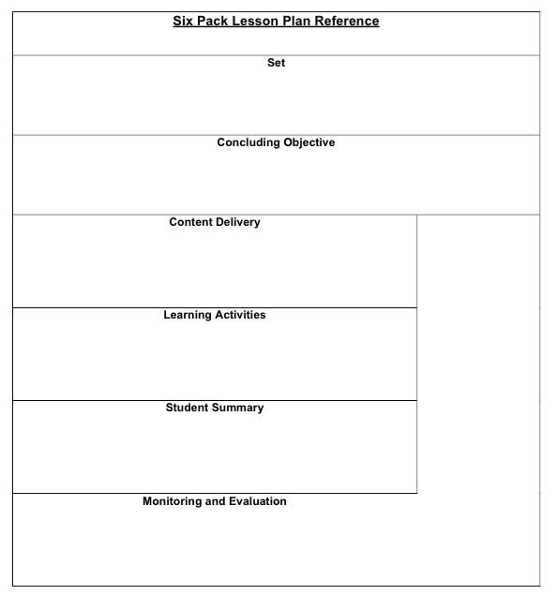

* Based on group size and equipment available form teams of at least three to practice application of a quick splint. 1 patient 2 rescuers.
* Instructor demonstrated process for students. ( I do )
* Follow skill sheet to reinforce process and assure all CPI’s are followed. (We do)
* If student is unsure of process use verbal cuing to reinforce process.
* When splint is applied and second CMS is assessed then use this time to debrief and offer reflection of the demonstrated processes.
* Use a second application to assess proficiency of skill objective ( You do)
* The student will apply a quick splint to secure a lower leg injury.

Share the visualization of a cold evening at your mountain with moderate wind. The wind chill drops temperature by 10 degrees. You arrive on scene to find a beginner skier in jeans no wind pants with a chief complaint of injured lower leg. Ask the questions about what do you have to consider here? Lead discussion to conclude you need to move quickly and secure the injury for transport.

* This lesson is intended to address the skill of lower leg splinting. By allowing students to learn in Mini Lesson format with smaller content mastery, the goal is to develop a strong foundation of learning that can be built upon.
* Instructors are encouraged to self-reflect on the lesson and make modification to improve their instruction for future lessons.
* Upon completion of quick splint application stop the group and check in with performance. Ask students what their “take away” is and are there any suggestions they would share with the group.
* This portion of the lesson allows the student to reflect back on their performance and make adjustments to the skill to improve or demonstrate their focus for growth.
* This can be done collaboratively or individually in a face-to-face fashion.
* Upon conclusion of the lesson students should develop an individual focus for growth.
* Structure of the lesson should follow the I do, We Do, You do format discussed in Mini Lesson
* Practicing primary assessment multiple times during the guided discovery portion of this lesson will anchor process aiding in reinforcing the concepts and objectives. Instructors will carefully observe and make corrections to student technique assuring success.
* Instructor observation requires a keen eye and correction if necessary.
* Reinforce skills by debriefing using chart paper or some other device to electronically document.

Assessment- Lower leg injury- Quick Splint