NAVIGATING THE OBSTACLE COURSE TOOLS
OBJECTIVES:
The student will be able to answer questions regarding the following:
How to register a course
How to edit a course
Student registration
Closing of a course
The proper “paper trail”

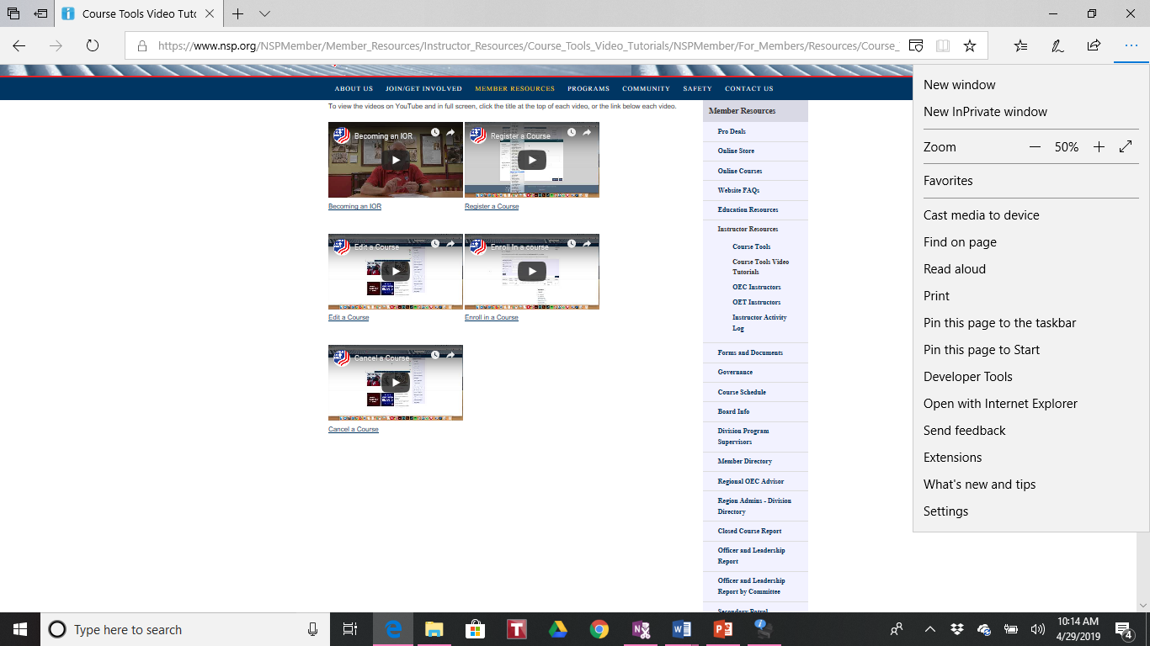

Course Tools Video Tutorials are on nsp.org for additional help

Register a Course:
- If you are registering an OEC, OEC on-line or OEC modified challenge be sure to put the date on which you need the test by.
- End date – usually a week after the actual end date in case there are any issues that need to be resolved first
- Assisting instructors. WARNING…Cannot be a student in the course
- Add notes: “by invitation only”, “closed course”, “please contact…”

If you are registering a course and you cannot see the particular IT you want to select:
- Select another IT from within your region and send an email to National asking them to change the IT selected to the IT you will have in attendance.
Use the + sign to “add” a new course

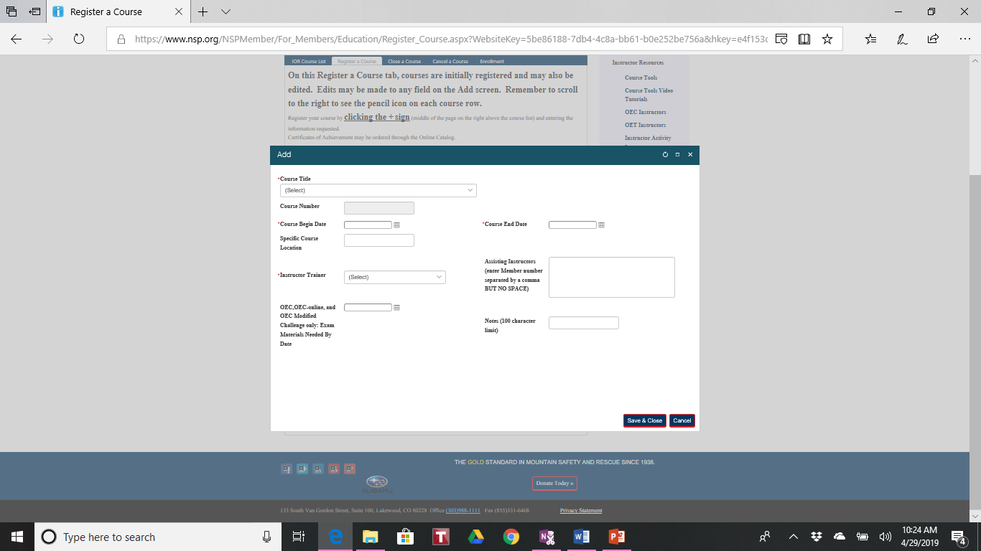

When you need to edit a course go back to the “register a course” tab and scroll down to the course you need to edit and use the pencil icon on the right of the selected course.

- If you are running a class that will be open to anyone interested you should contact the Regional webmaster and the Division Webmaster to have it added to the calendar.

- If this course is “by invitation only” or a “closed course” you should send the course number and instructions to the group of individuals you need to register.

WHEN REGISTERING FOR A COURSE:

- Attendees MUST register for a course prior to attending
- An IOR will not receive credit as a student
- Registrants need to register as a student OR an instructor but cannot register as both
- When enrolling in a course be sure to hit the “submit” button at the bottom of the screen

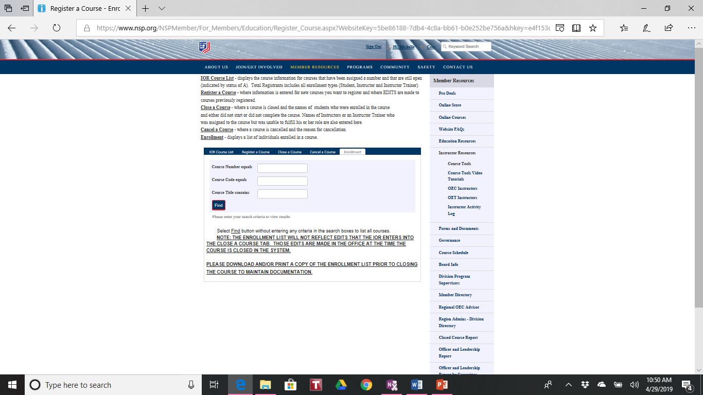

BEFORE YOU CLOSE A COURSE:

- Print and/or save a roster of all registrants for your class before you close it
- Be sure all attendees are showing on the roster
- Double check that those registered as instructors are not registered as students as well
- Be sure that all visiting patrollers were registered
- Sign the appropriate paperwork for them to return to their PD
- Close your course in a timely manner to be sure patrollers receive credit for attending

COMMUNICATION WITH YOUR IT:

Send an email to the IT with the following information:
- The roster of those in attendance
- Any notes that you sent when closing the course
- Note those that were successful and those that were not successful

CLOSING A COURSE:

THE ENROLLMENT LIST WILL NOT REFLECT EDITS THAT THE IOR ENTERS INTO THE CLOSE A COURSE TAB. THOSE EDITS ARE MADE IN THE OFFICE AT THE TIME THE COURSE IS CLOSED IN THE SYSTEM.

IF YOU ARE CLOSING AN OEC COURSE AND A STUDENT IS INCOMLETE BUT DID NOT FAIL, PLEASE EMAIL EDUCATION@NSP.ORG PRIOR TO CLOSURE TO TRANSFER THAT STUDENT TO A DIFFERENT COURSE.

PLEASE DOWNLOAD AN/OR PRINT A COPY OF THE ENROLLMENT LIST PRIOR TO CLOSING THE COURSE TO MAINTAIN DOCUMENTATION

PLEASE DO NOT CLOSE COURSES THAT WERE REGISTERED BUT DID NOT OCCUR. THOSE COURSES SHOULD BE CANCELLED USING THE CANCEL A COURS TAB SO MEMBER RECORDS ARE NOT INACCURATELY POPULATED.

IF YOU NEED TO CANCEL A COURSE USE THE “CANCEL COURSE” TAB. BE SURE TO ADD A REASON FOR THE CANCELLATION.

IT (INSTRUCTOR TRAINER) PIECE OF THE PUZZLE

- The IT will receive an email from National asking for their approval to close the course – please do so immediately as this is a crucial step in the final process
- The IT sends the QA evaluation to the IOR, ROA, OEC Assistant Supervisor and National.

